**COIT13235: Enterprise Software Development (HT2, 2024)**

**Assignment 2 Project :**

**Screamer Application**

Unit Coordinator : Jamie Shield

Tutor : Wie Kiang Hi

Name: Roshan Phakami Punmagar / Student Id: 12201590

**User Story**

* As a Admin, I can can block Movies.
* As a Admin, I can can unblock Movies.
* As a Admin, I can block users.
* As a Admin, I can unblock users.
* As a user can access web app
* As a user I can register a new account
* As user, I can see recommendation
* As user, I can watch Movies
* As user, I can add movie in watchlist
* As user, I can remove movie in watchlist

**Functional Requirements**

* User Registration and Authentication: The system allow to user can register, login and logout securely
* Recommendations: The application provide every time random movie recommendations.
* Watchlist: Users can add, remove, and view movies in their watchlist.
* Admin : Admin can be able to Block/unblock user and also block/unblock Movies.
* Movies: User can watch Movie.

**Non-Functional Requirements**

* Performance: Under typical demand, the program should reply to user queries in two seconds.
* Security: The system must prevent unwanted access and all user data must be encrypted.
* Usability: the user interface should be simple to use and accessible.

**Installation Guides**

* Unzip Spring2Assignment folder.
* Right click open folder in netbeans.
* Select all the project admin, DatabseDao,Recommendation, Screamer, screamerWebApp in netbeans.
* Click on Open Project and run project.

**Sequence for run microservices**

Services can be run out of order however is recommended to run in this order for fastest start up

1) Server

2) DatabaseDao

3) Admin

4) Recommendation

5) Screamer

6) ScreamerWebApp

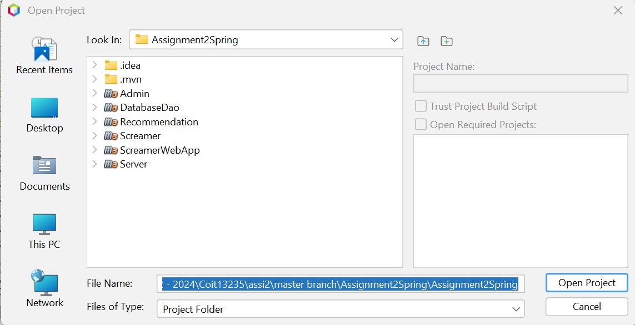

**Git hub link**

<https://github.com/relife-e/Assignment2Spring>

**Testing – Test Plan and Test results**

* http://localhost:8761

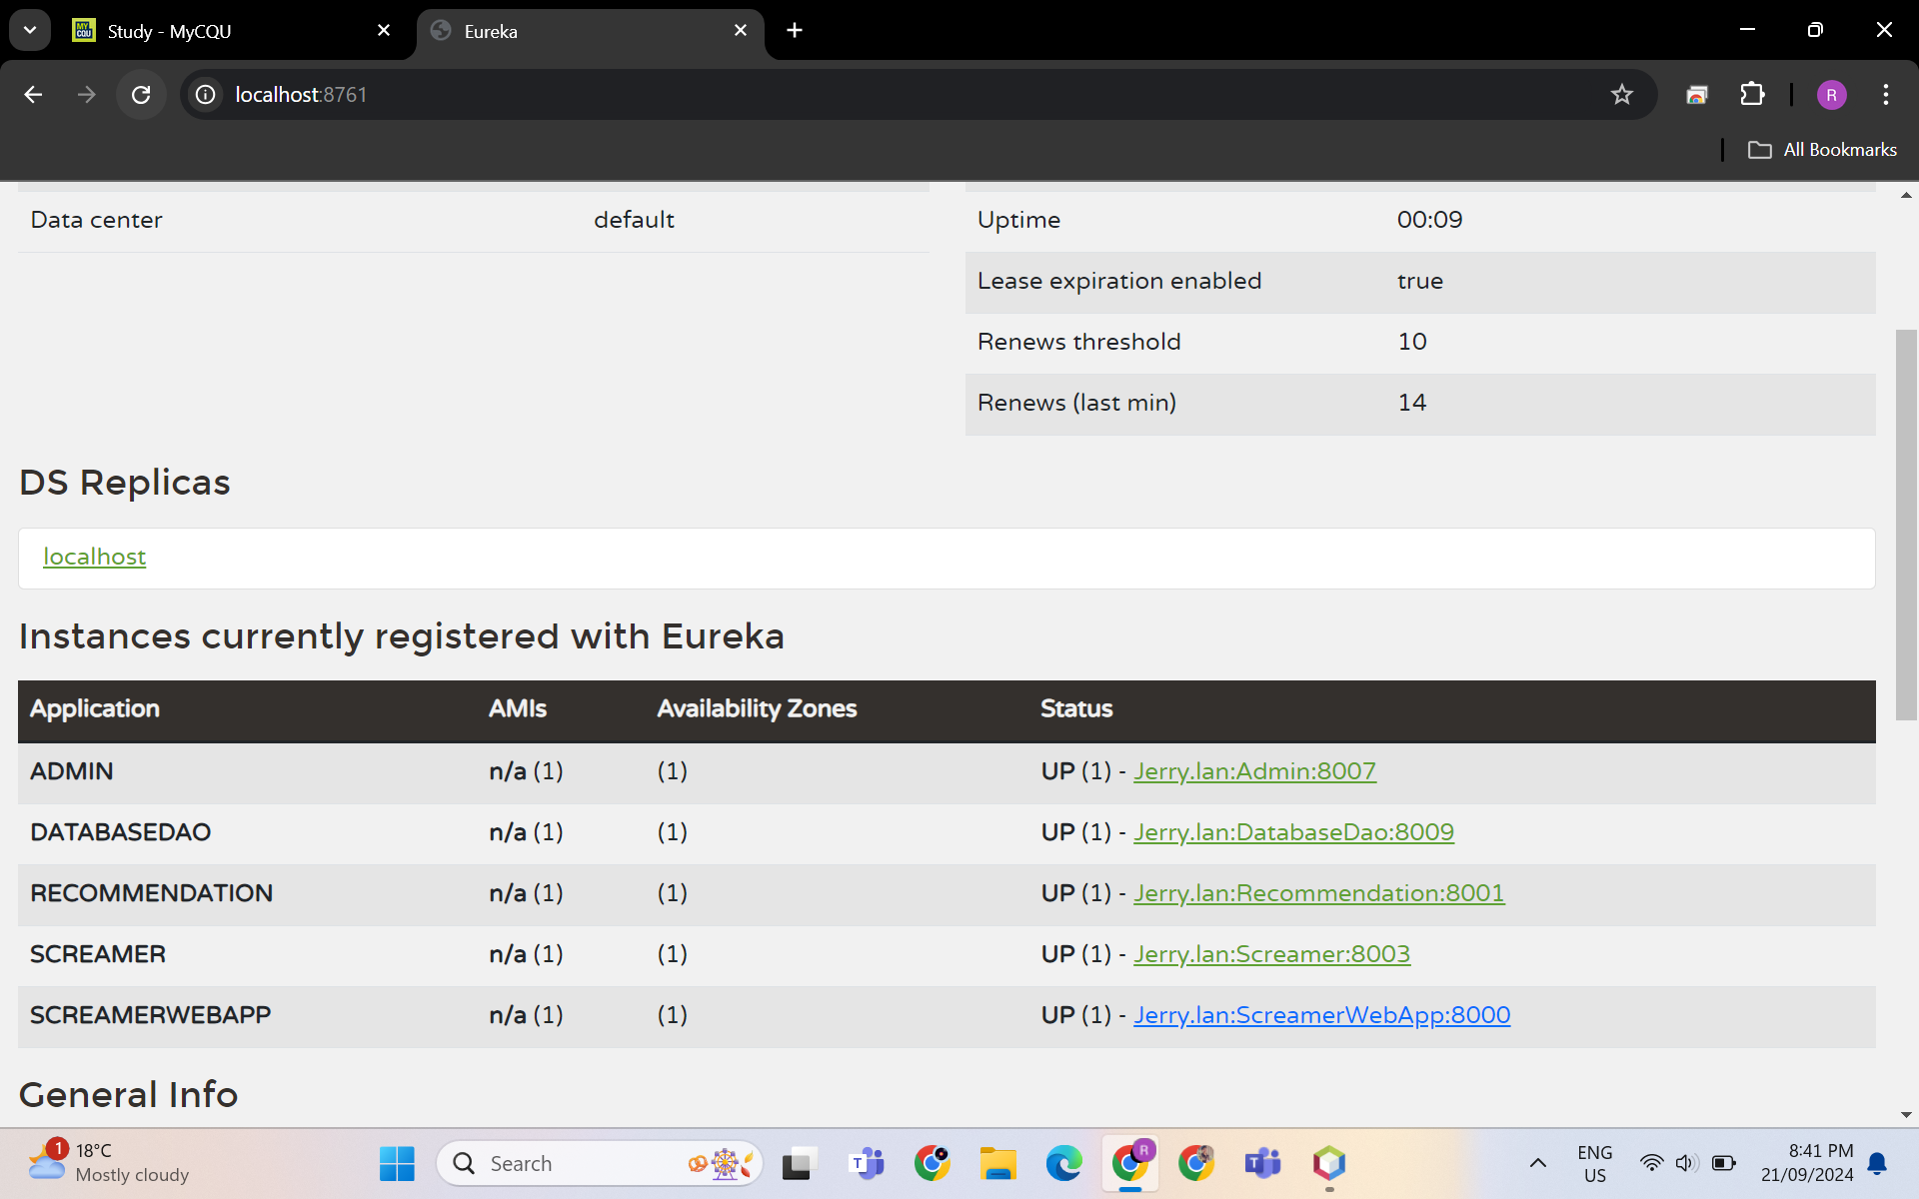

* Open Screamer web app its redirect login page. Login as a user.

Email: [rutvi@gmail.com](mailto:rutvi@gmail.com)

Pwd : rutvi123

* Welcome screen.

* Click on View all Movies for view all movie

* Movie Page

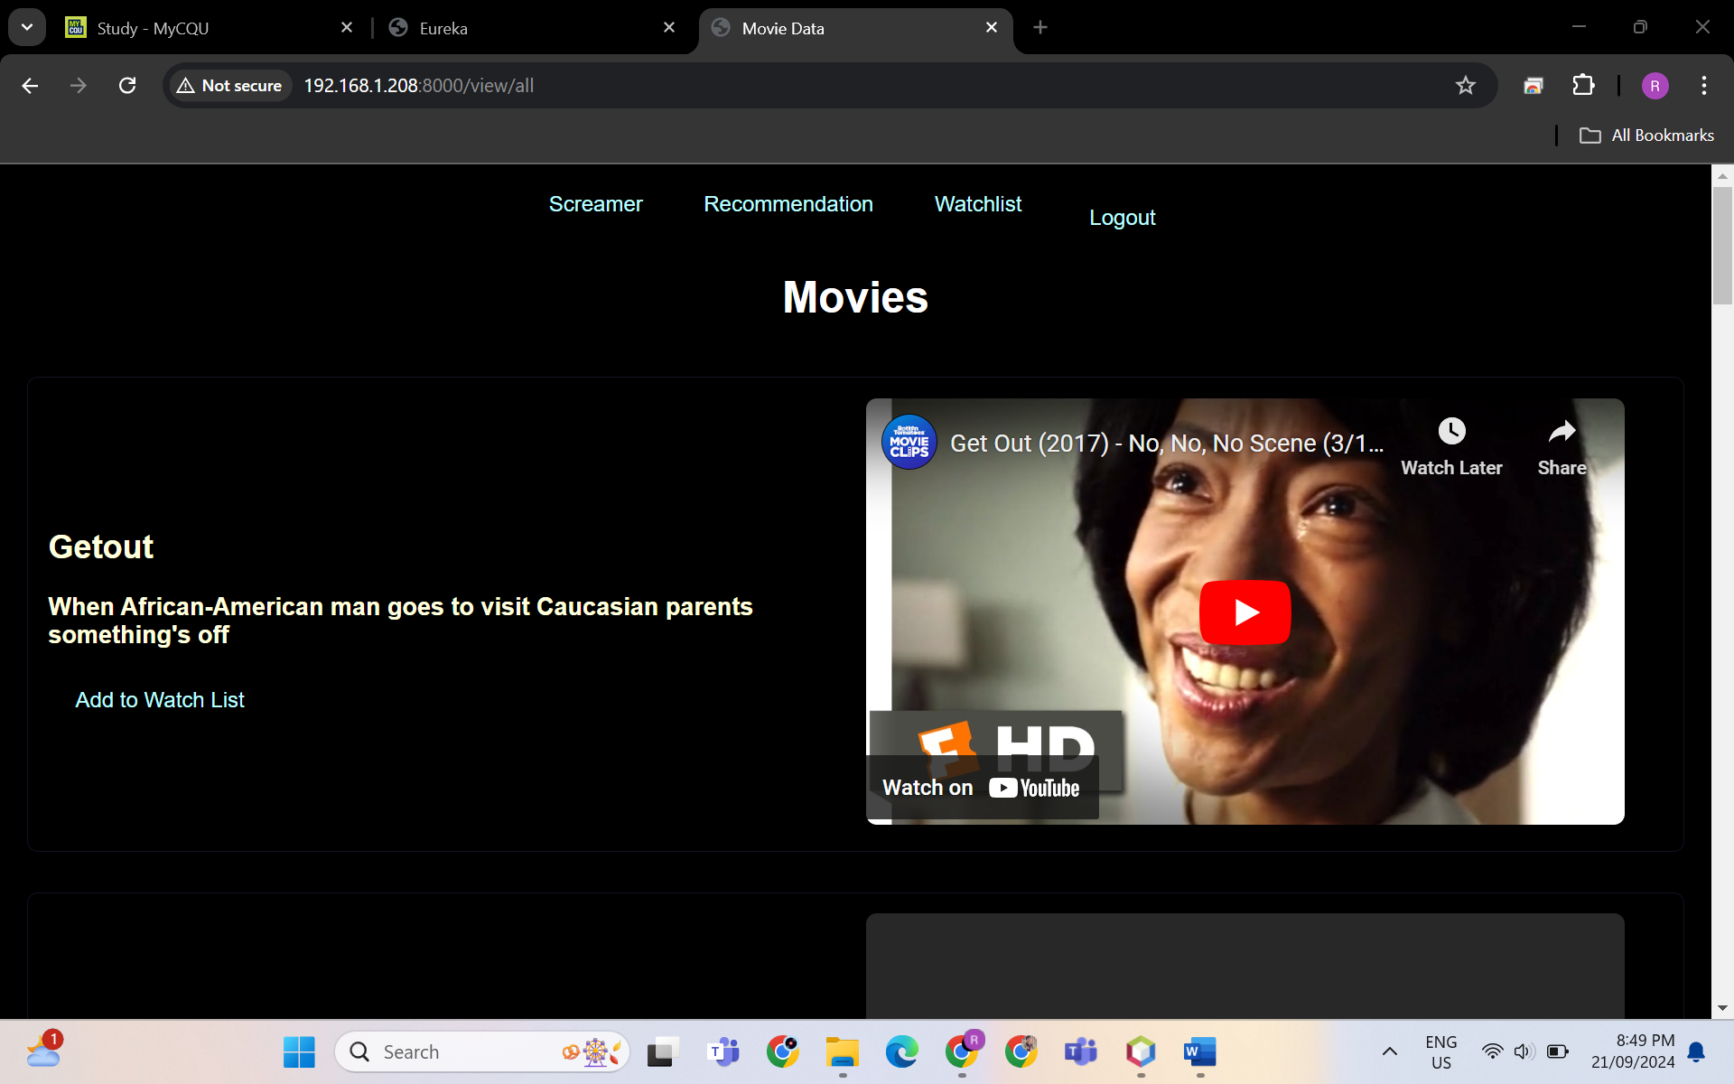

* Recommendation Page - As user, I can see recommendation

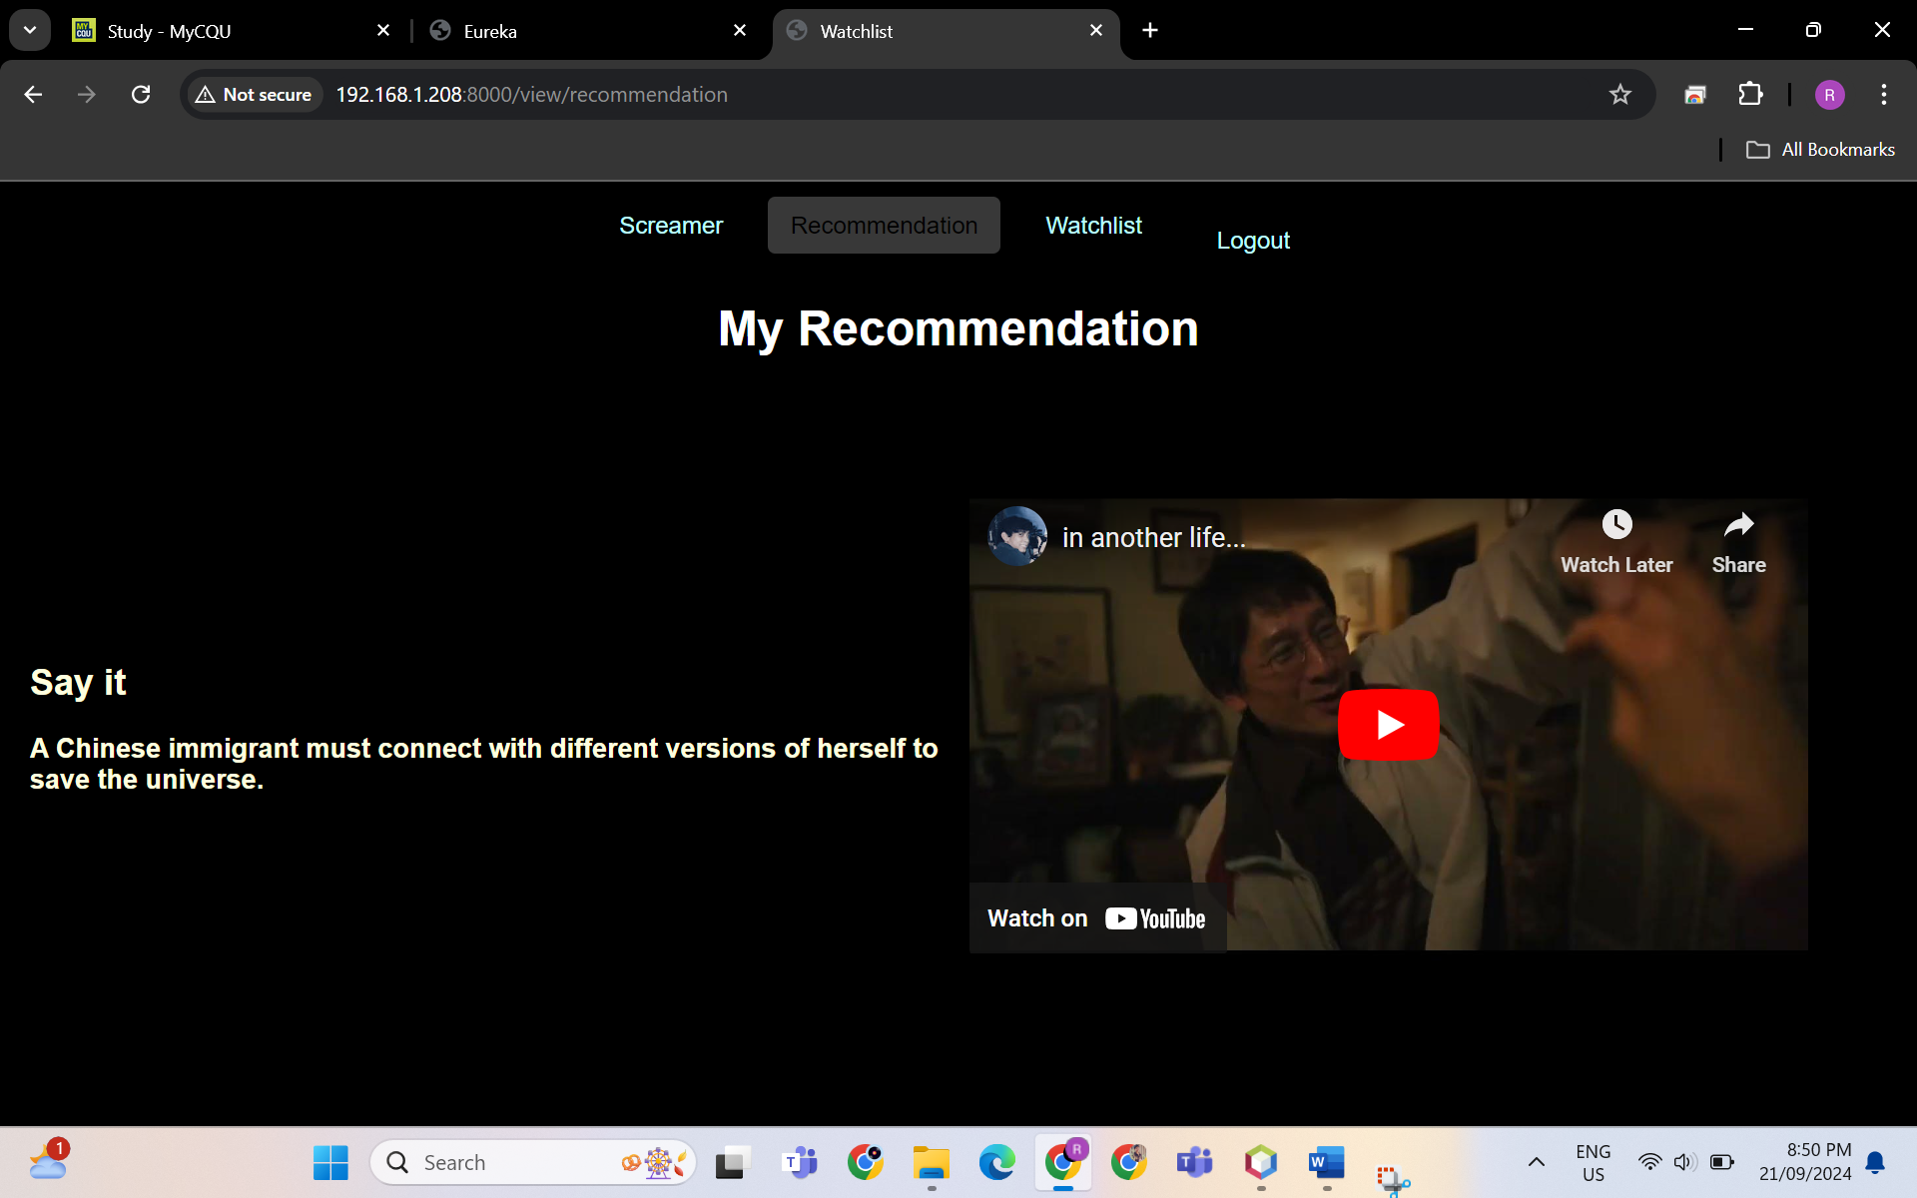

* My watchlist page before add movie - As user, I can add movie in watchlist

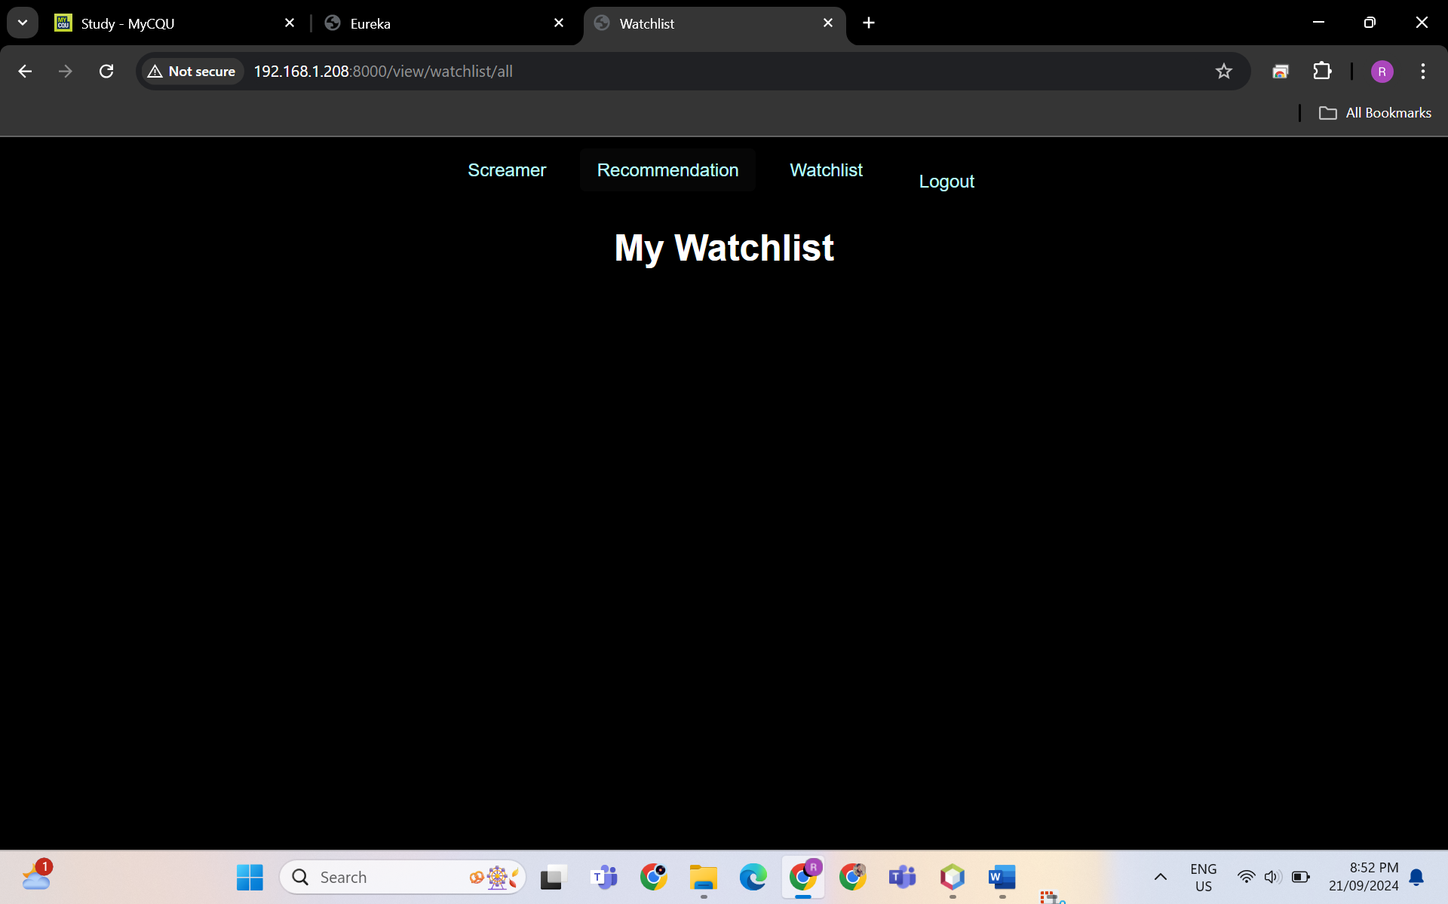

* Movie add into watch list

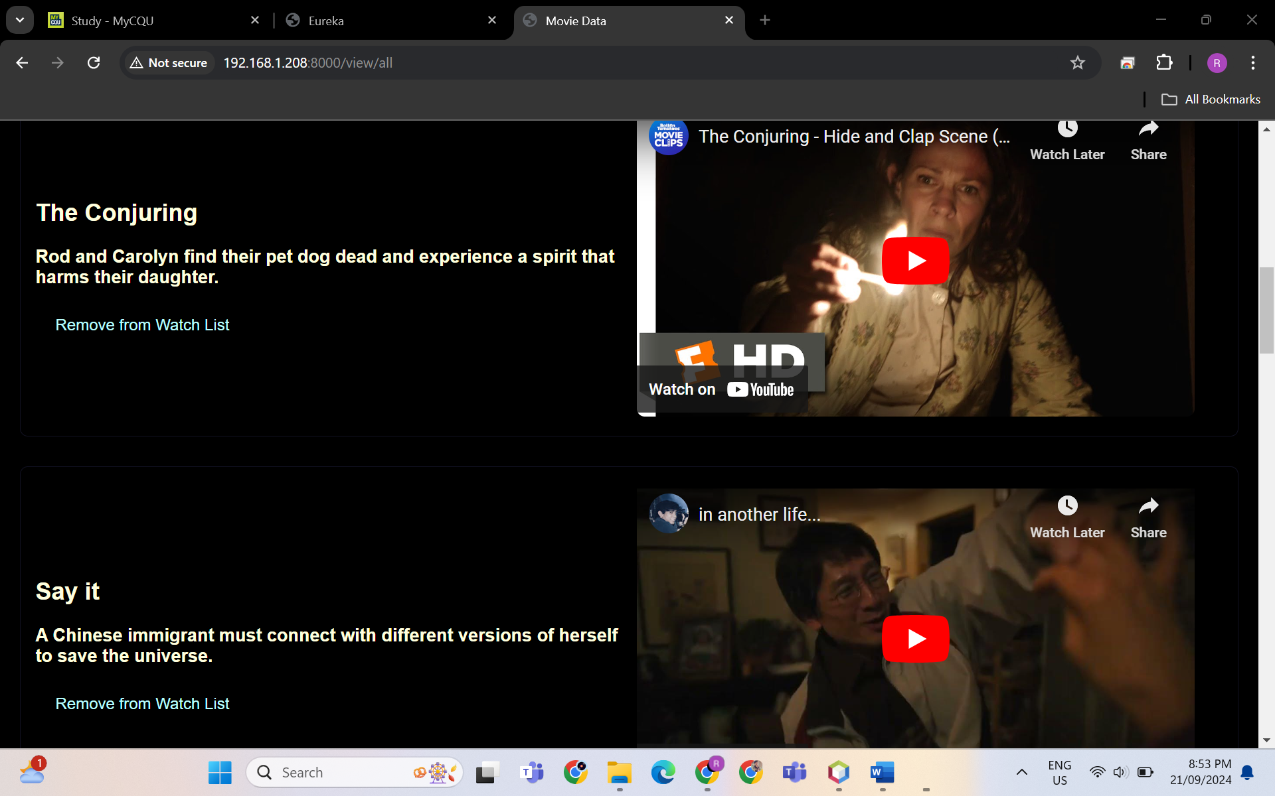

* My watchlist after add movies

* As user, I can remove movie in watchlist

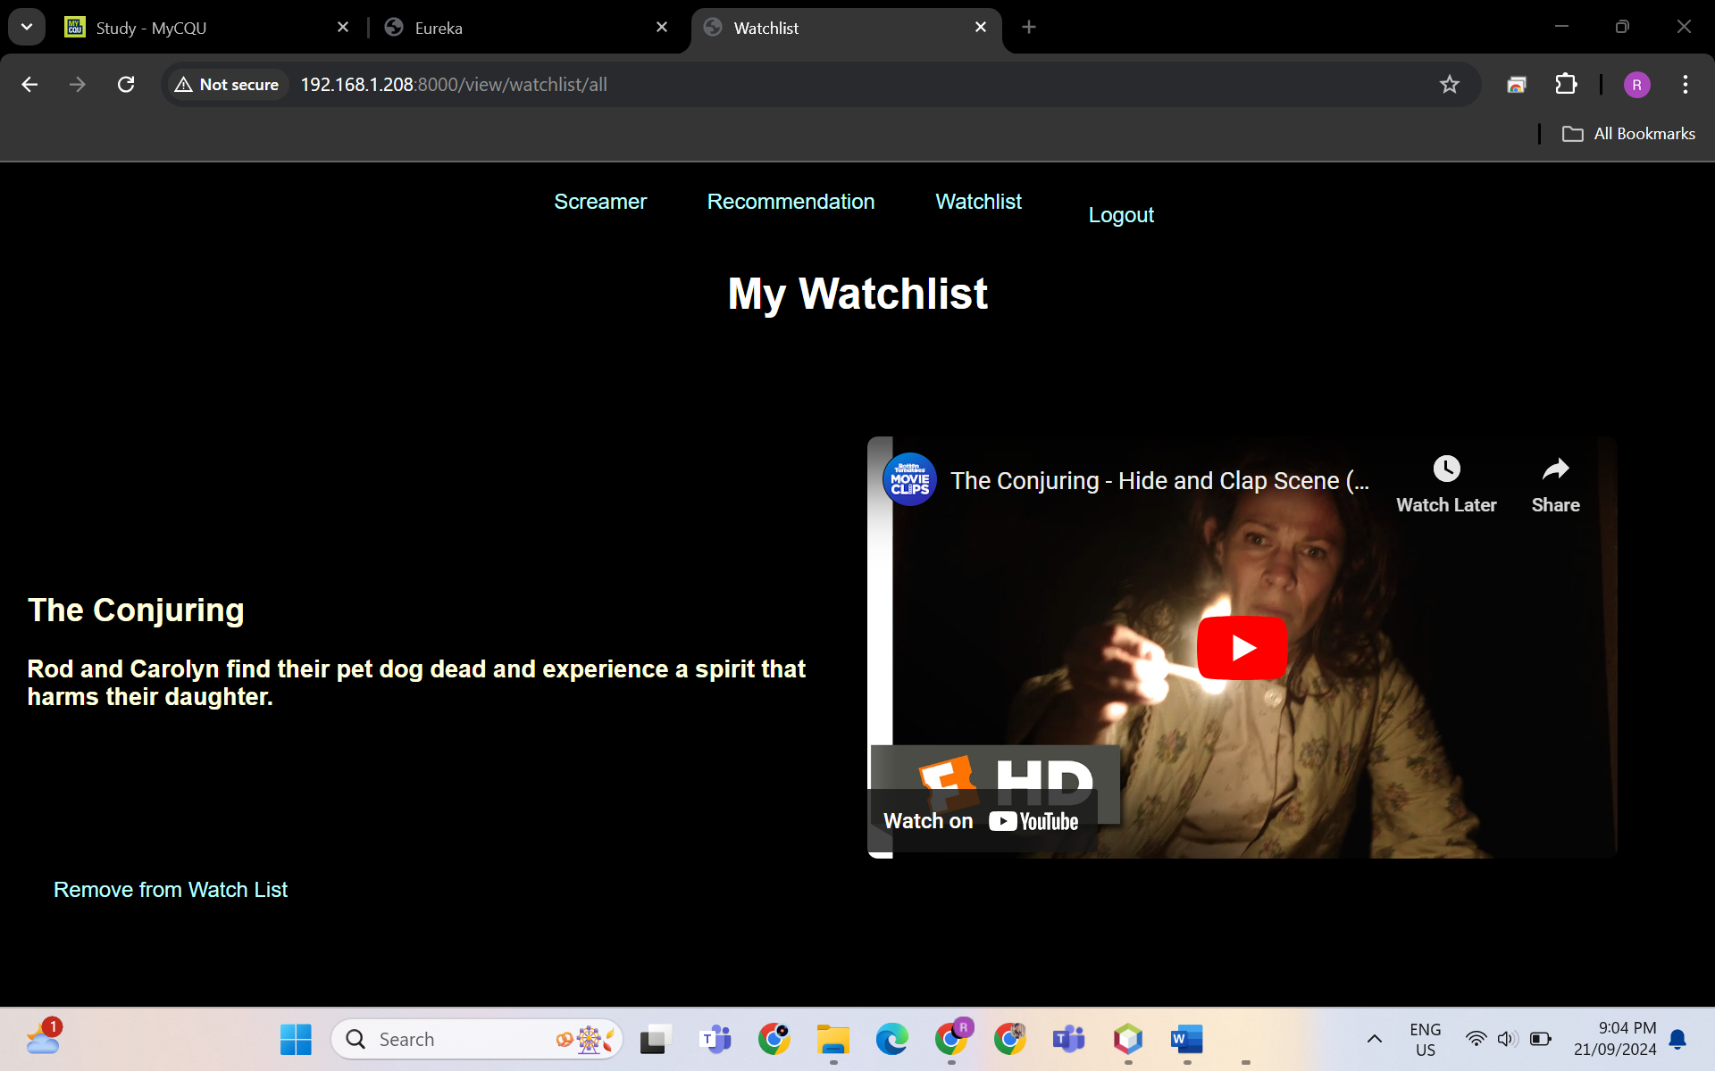

* Login as Admin

Email : [anmol@gmail.com](mailto:anmol@gmail.com)

Pwd: anmol123

* As a Admin, I can block users.

* As a Admin, I can unblock users.

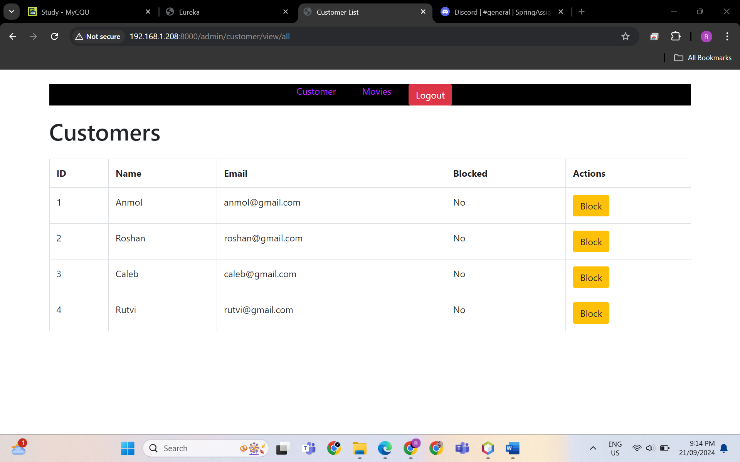

* As a Admin, I can block users.

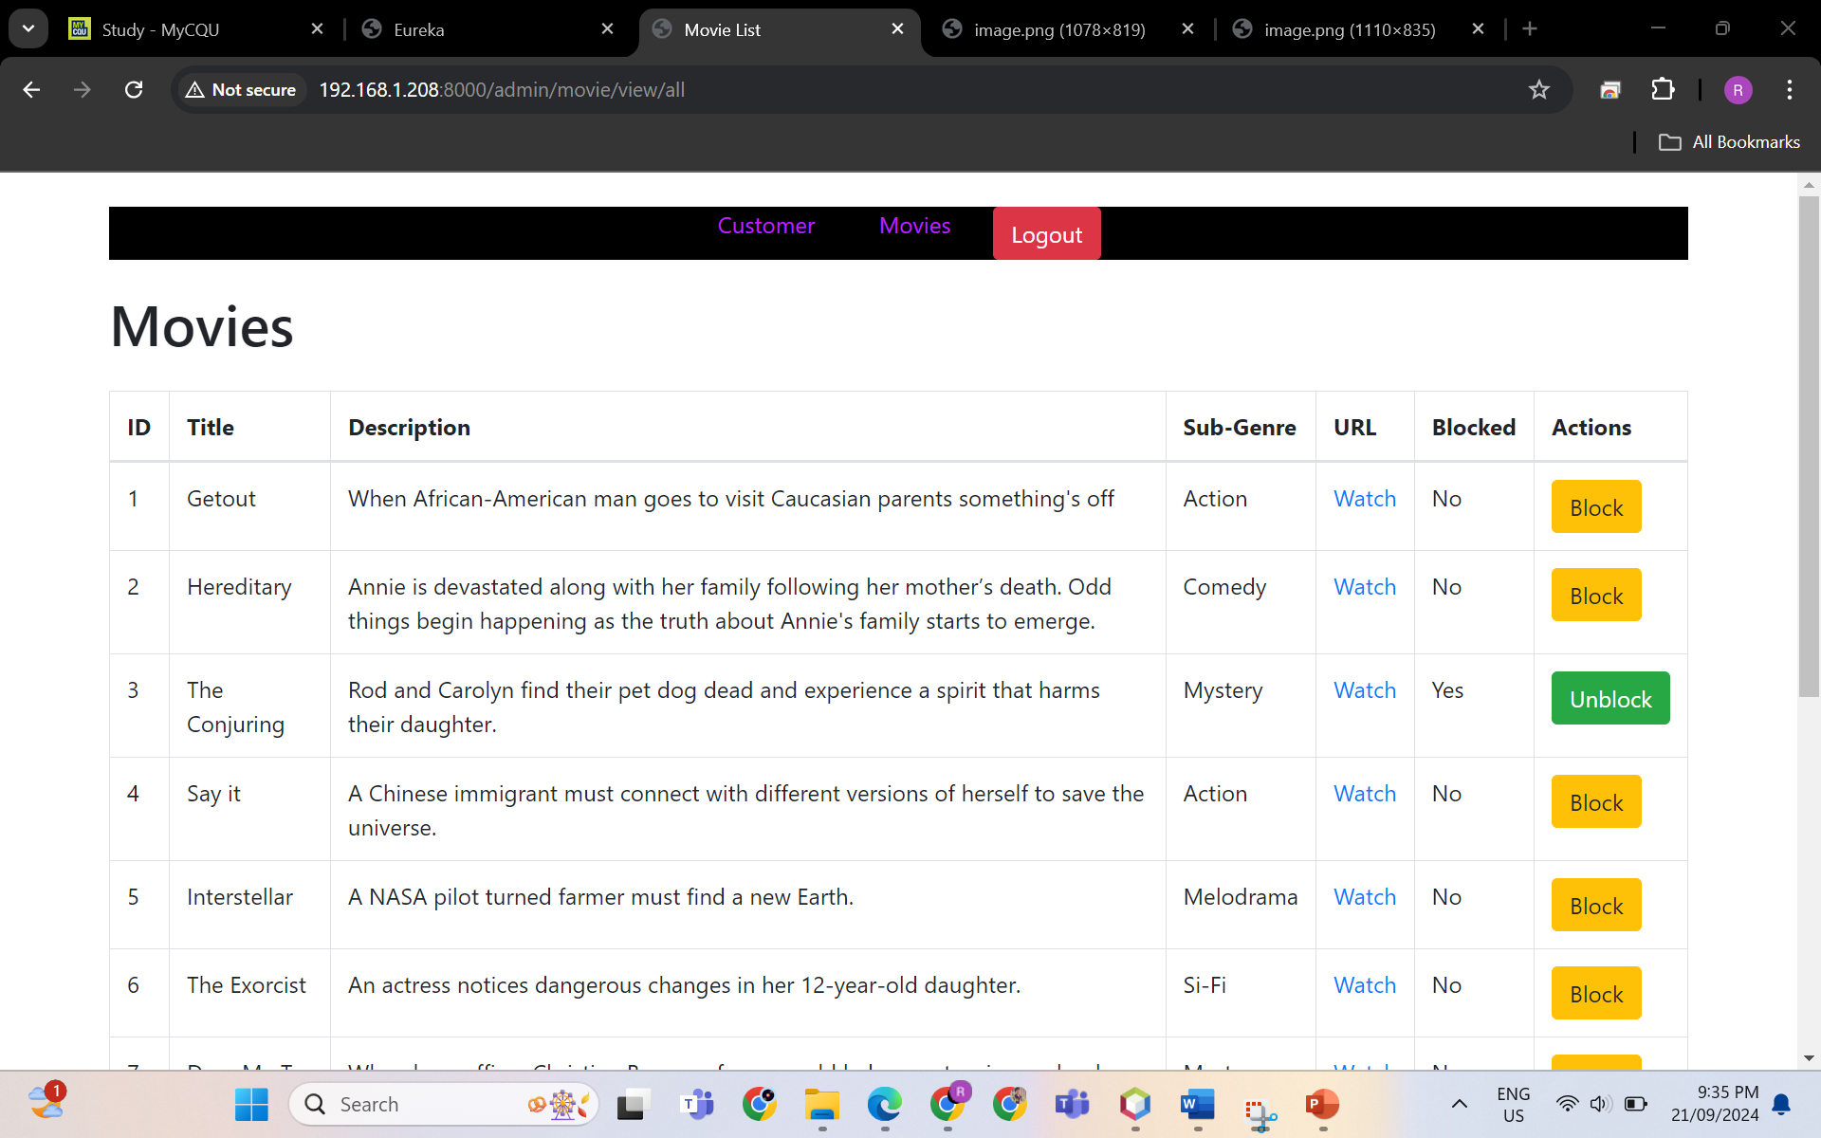

* As a Admin, I can unblock users.

* As a user I can register a new account

